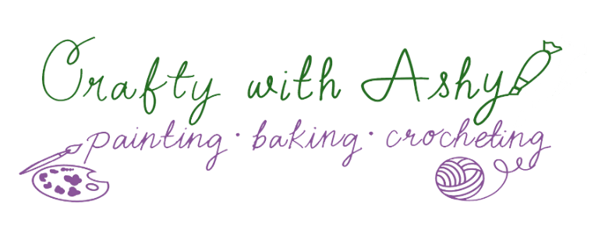 Crochet Minnesota Vikings Logo

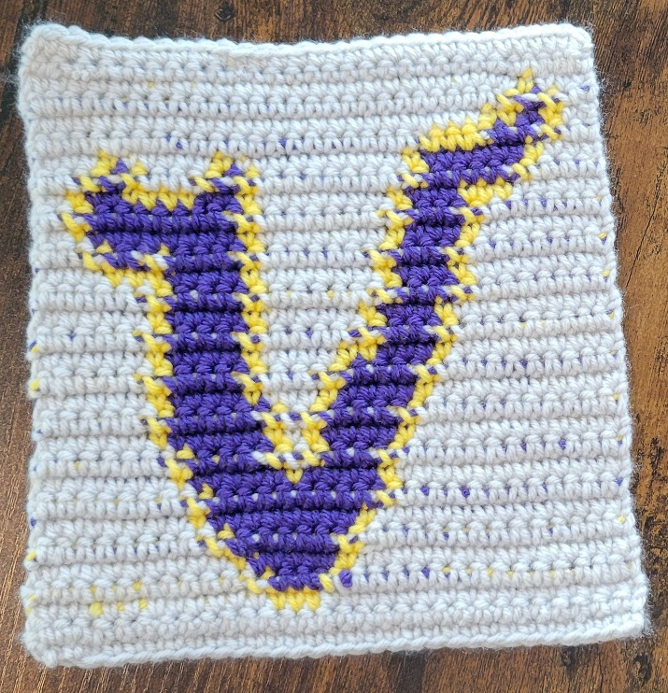

Pattern notes:
- Do not do turning chains (after the foundation chain row)
- When changing colors during the single crochet stitch: yarn over, insert hook, pull up loop, change colors then pull a loop through both loops on hook.

Materials:

- “I Love This Yarn” Medium weight Acrylic yarn: approx. 0.8 oz Light Grey (color A), approx. 0.5 oz Yellow (color B), appox. 0.5 oz Purple (color C)
- Size G/4.25 mm crochet hook
- Darning needle
- Scissors

© 2026 CraftywithAshy

